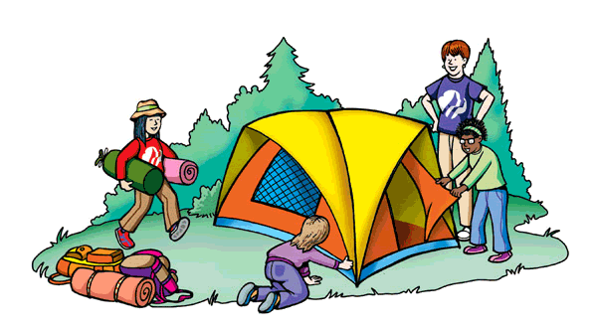

Camping Essentials Checklist

Shelter:
- Tent- including rainfly, poles, and stakes
- Sleeping bags and pillows
- Sleeping pad or blow up mattress and pump
Kitchen:
- Stove and fuel
- Firestarter- matches, lighter, paper, etc.
- Pots and pans
- Hot pads/ oven mitts
- Cooking utensils- spatula, tongs, serving spoon
- Can opener
- Sharp knife and cutting board
- Foil
- Trash bags
- Zip lock bags- both gallon and quart sizes
- Paper- plates, bowls, cups and eating utensils
- Paper towels
- Ice chest and ice
- Biodegradable dish soap
- Wash cloths and trying towels
- Basin to wash dishes in
- Water- jugs and bottles if not at the site

Personal:
- Toilet paper
- Sun screen and insect spray
- First aid kit
- Toothbrush and tooth paste, hair brush and hair ties
- Towels
- Hand sanitizer
- Feminine hygiene products
Clothing:

- Lightweight T-shirts
- Hoodie and jacket
- Jeans
- Shorts and swimsuit
- Hats and gloves
- Boots/hiking shoes
- Socks and underwear
Misc:
- Duct tape
- Basic set of home tools
- Paracord
- Flashlight, lantern, EXTRA BATTERIES
- Axe- small for chopping wood
- Multitool
- Camping chairs and table
- Toys
Keep in mind that this list is only basic. Soon you’ll be able to tailor these things to your families. Please feel free to contact me if there is something I’ve forgotten about. HAPPY CAMPING!!!

